ICS123 Final Project

1, Game Design

**Mechanics:**

* Single player shoot enemies in the scene to collect 10 collectable items created in Lab 10.

**Objective:**

* when the player collects 10 of the items without dying, the message pops up saying he’s got 10 collectable item and he gets a reward of a new machine gun(or just pop up a message “you survived”

**Rules:**

* The player can kill any enemy in the scene
* The player can walk up to a wall through a ramp and jump off a wall
* The player can run anywhere in the play scene
* The player can push any object away from him in the play scene

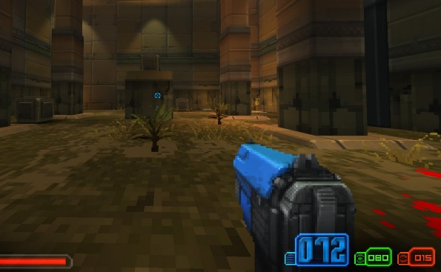**Aesthetic:**

* Rusty environment like the picture shows:
* Add more 3d objects sucks trees, wooden boxes or rocks

**Hardware:**

* Intel Core i7-6700 CPU
* 8.0 GB of RAM
* Keyboard and Mouse

**Narrative:**

* when the player collects 10 of the items without dying, the message pops up saying he’s got 10 collectable item and he gets a reward of a new machine gun(or just pop up a message “you survived”

**Top-Down prototype:**

* Add later

**Game Development:**

* Lab2, make the scene bigger, add more walls, and some irregular walls
* Lab6, add more textures, partical systems and props
* Lab8/9, add more to 2D GUI. When the player is shot, a message pops up “sorry, I tried my best”

**Playtesting:**